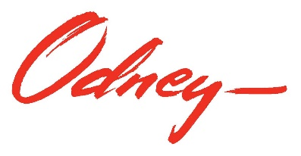

North Dakota Department of Transportation
March 2021 Organic Social Media Post Plan – Facebook, Instagram and Twitter
March 1, 2021

Once approved, the following draft posts will be used to populate the Vision Zero ND Facebook page, Instagram account and Twitter account (with character limit adjustments) for the month of March 2021. Additional posts may be recommended throughout the month based on newsworthy stories or unique opportunities that present themselves after this plan is approved. Those additional posts will be presented to NDDOT for approval before posting.

March 1: Parents, do you need some help teaching your kids the importance of wearing a seat belt? Share this video with them! It’s never too early to learn safe driving habits. #BuckleUp #VisionZeroND #NDDOT
https://youtu.be/neheXjYd1Xw

March 2: Wearing a bulky coat in the vehicle can jeopardize the snug fit in your child’s car seat. Put their coat on backwards over the properly fitted harness to keep them warm. #TheRightSeat #NDDOT #VisionZeroND #NDDoH
https://www.nhtsa.gov/road-safety/child-safety
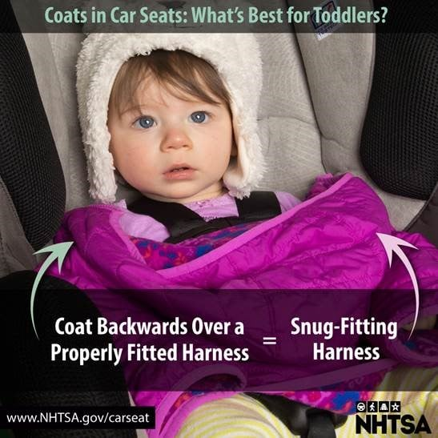

March 2: Today we announced a new Vision Zero program – ND Sober Ride. A program aimed at reducing the number of impaired drivers on North Dakota roads through ride-hailing vouchers.

Starting TODAY, Use @Lyft code “NDSoberRide” for $10 off a ride from 5pm – 2am. Available while codes last. This specific code can only be used once.

Thank you to our sponsor, @AAA – The Auto Club Group, for providing the funds to make codes possible.
#NDSoberRide #VisionZeroND #Lyft
https://visionzero.nd.gov/strategies/ImpairedDriving/NDSoberRide
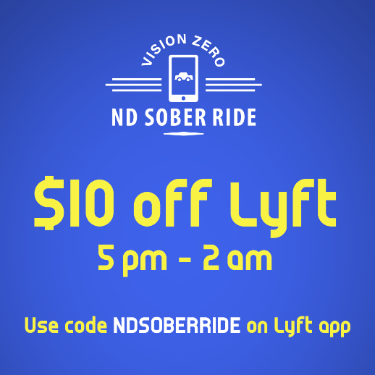

March 3: Want to help us promote traffic safety? Join the Vision Zero Partner Network! #VisionZeroND https://visionzero.nd.gov/partner-safety-network/JointhePartnerNetwork/

March 4: The failure to wear a seat belt results in more motor vehicle fatalities in North Dakota than most other factors. #BuckleUp #VisionZeroND #NDDOT
https://visionzero.nd.gov/strategies/OccupantProtection/
Creative: Paid Native American Creative

March 5: 17 too many. Every driver in North Dakota can help meet the Vision Zero goal by taking personal responsibly when driving. #ZeroFatalities #ZeroExcuses #VisionZeroND #NDDOT
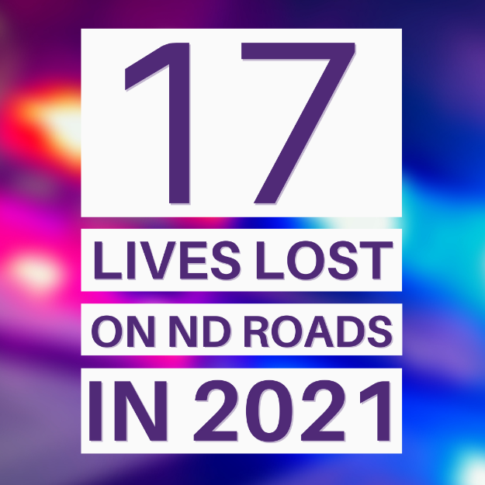

March 6: Safe driving is an attitude. Practicing good behaviors and attitudes on the road are key to enhancing traffic safety. You are either the victim or the culprit of bad behavior on the roads. Do your part and practice safe driving. #SafetySaturday #VisionZeroND #NDDOT
Creative: “Safe Driving is an attitude”

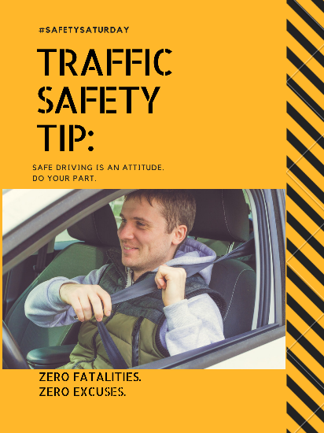

March 7: Law enforcement and first responders put their lives at risk when they set foot on the side of the road. Keep them safe by following the law – Move over. #MoveOverND #VisionZeroND #NDDOT #NDHP

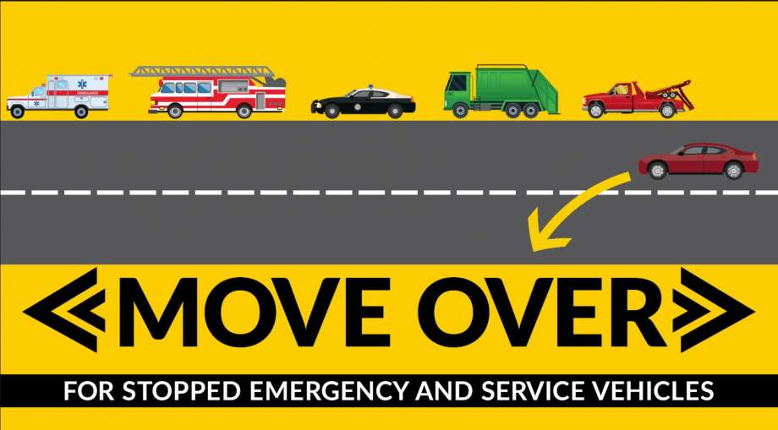

March 8: Daylight Saving Time is coming up on March 14. Use this time to set the clock forward, check smoke detectors, and check your VIN for recalls. #CheckForRecalls #VisionZeroND #NDDOT
NHTSA.gov/recalls

March 9: Obey speed limits and keep yourself and others on the road safe. #StopSpeedingBeforeItStopsYou #VisionZeroND #NDDOT
https://visionzero.nd.gov/strategies/SpeedAggressiveDriving/

March 10: Are you going to the @NorthDakotaWinterShow in Valley City this weekend? Look for this Snapchat filter while you’re there and remember to always drive sober or find a sober ride! #NDWinterShow #VisionZeroND #NDDOT

March 11: Good luck to everyone competing in the Class A Basketball Tournament this weekend! Remember to buckle up as you travel to Bismarck. #VisionZeroND #NDDOT #NDHP
https://visionzero.nd.gov/strategies/OccupantProtection/

March 12: Happy Spring Break! Before you pack up and head to your destination, brush up on these responsible driving tips! #VisionZeroND #NDDOT #NDHP
http://trafficsafetyguy.com/8-safe-driving-tips-during-spring-break/?fbclid=IwAR3wduIJ3xV9QVR7WU5DN8SIS2odW4BlHhwQtsBDviCw0UFMMVi-840ffhM

March 12: Happy Friday! ND Sober Ride has you covered for getting a sober ride this weekend. Use @Lyft code “NDSoberRide” for $10 off a ride from 5pm – 2am. Available while codes last.

Thank you to our sponsor, @AAA – The Auto Club Group, for providing the funds to make codes possible.
#NDSoberRide #VisionZeroND #Lyft
https://visionzero.nd.gov/strategies/ImpairedDriving/NDSoberRide

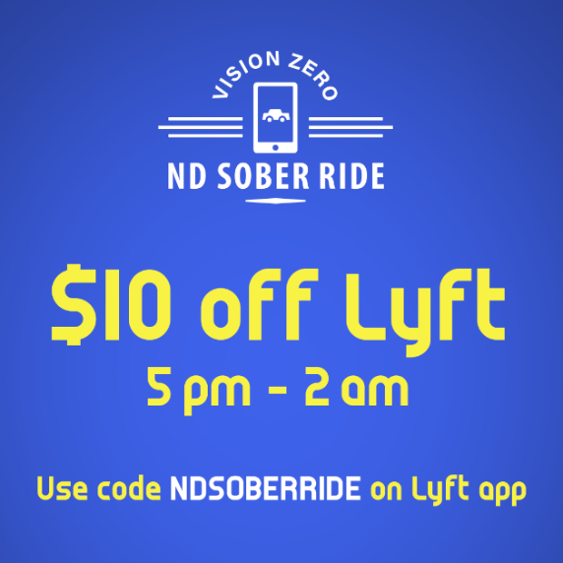

March 13: Are you channeling your inner leprechaun and going to the Pub Crawl today? Here’s a tip: Don’t rely on the “luck of the Irish” to get you home safely. Plan for a sober ride home! #SafetySaturday

March 14: It’s time to Spring Forward! Remember to set your clock an hour ahead and #CheckForRecalls! #VisionZeroND #NDDOT
https://www.trafficsafetymarketing.gov/sites/tsm.gov/files/nhtsa_turn_clocks_forward_h264.mp4

March 15: Want to help us promote traffic safety? Join the Vision Zero Partner Network! #VisionZeroND https://visionzero.nd.gov/partner-safety-network/JointhePartnerNetwork/

March 16: In 2019, there were 43 people who died in a crash caused by impaired driving. We can do better. Get home safe to your loved ones. #DriveSober #VisionZeroND #NDDOT
https://visionzero.nd.gov/strategies/ImpairedDriving/

March 17: Don’t push your luck this St. Patrick’s Day!🍀 Use Lyft code “NDSoberRide” for $10 off a ride from 5pm - 2am. Available while codes last.

Thank you to our sponsor, @AAA – The Auto Club Group, for providing the funds to make codes possible.
#NDSoberRide #VisionZeroND #Lyft
https://visionzero.nd.gov/strategies/ImpairedDriving/NDSoberRide

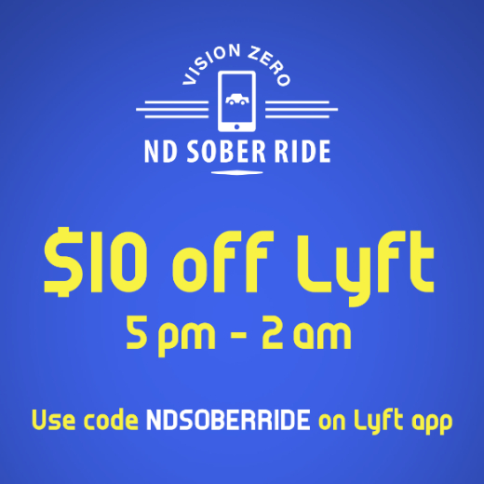

March 17: No “Irish Luck” can get you out of this. If you plan to drink alcohol, designate a sober ride home. #DriveSober #VisionZeroND #NDDOT
https://visionzero.nd.gov/strategies/ImpairedDriving/

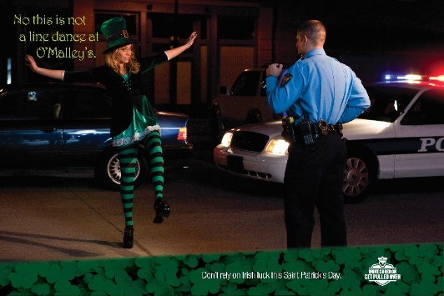

March 18: Headed to Minot for the Class B Basketball Tournament? Remember to buckle up and drive distraction free as you travel to support your team! #NDDOT #VisionZeroND #NDHP
https://visionzero.nd.gov/strategies/

March 19: Happy First Day of Spring! If you plan to get out and enjoy the day, remember to buckle up! #VisionZeroND #NDDOT
March 20: Night Driving – the most dangerous time to drive. Here are a few tips :
✔Dim your dash lights to allow your eyes to better adjust to the darkness.
✔Don’t stare at oncoming lights. Lower your gaze but focus on the road ahead.
✔Look out for animal eyes reflecting from your headlights so you have time to slow down.
#SafetySaturday #VisionZeroND #NDDOT

March 21: Just because it’s officially spring, doesn’t mean winter weather is behind us. Roads can still be icy so remember to drive with caution! #VisionZeroND #NDDOT
https://visionzero.nd.gov/strategies/winterdriving/

March 22: Is it time for your teen to get their driver’s license? Check out these helpful tips that every parent should know. #TeenDriverSafety #VisionZeroND #NDDOT
https://zerofatalities.com/ready-for-driver-license/

March 23: Vision Zero Schools gives students the opportunity to be traffic safety advocates and to build their resume. Interested in becoming a Vison Zero School? Visit our website to learn more!
https://visionzero.nd.gov/partners/visionzeroschools/

March 24: Cameron’s heart was full of kindness, compassion, and a love that made everyone feel appreciated. He was a passenger in a vehicle with a distracted driver. See Cameron’s story on our Crash Memorial Wall. #CrashMemorial #VisionZeroND #NDDOT
https://visionzero.nd.gov/memorial/Cameron-Bolton/

March 25: Going out this weekend?🍺 Take advantage of the new Vision Zero program – ND Sober Ride. Use @Lyft code “NDSoberRide” for $10 off a ride from 5pm – 2am. Available while codes last.

Thank you to our sponsor, @AAA, for providing the funds to make codes possible.
#NDSoberRide #VisionZeroND #Lyft
https://visionzero.nd.gov/strategies/ImpairedDriving/NDSoberRide
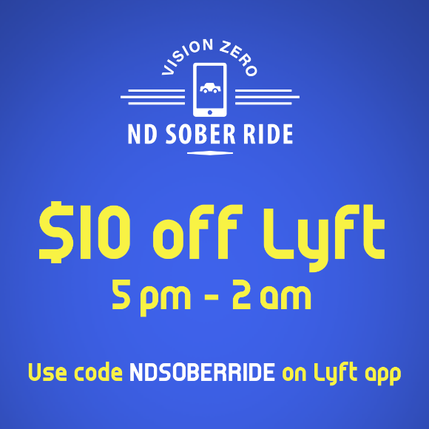

March 25: @ImpactTeenDrivers is offering a free, interactive online program to prevent the #1 killer of teens – distracted driving. Sign your teens up to bring this lifesaving message to North Dakota’s youth! Visit the Impact Teen Drivers website for more information.
https://www.impactteendrivers.org/NorthDakota

March 26: Join us on the road to zero fatalities. Reaching our goal starts with you. Drive responsibly for your loved ones. #VisionZeroND #NDDOT
https://visionzero.nd.gov/strategies/

March 27: What to do when the unexpected happens on the road?
✔If you can safely move in traffic, pull over to the right.
✔Stay in your car and keep your seat belt on.
✔Call 9-1-1.
#SafetySaturday #VisionZeroND #NDDOT
https://zerofatalities.com/all-drivers/

March 28: Are you a member of our Vision Zero Partner Network? Marketing and educational materials are free, and all contributions are voluntary – join today to help promote traffic safety! #VisionZeroND
https://visionzero.nd.gov/partner-safety-network/JointhePartnerNetwork/

March 29: Of the 91 fatal crashes on North Dakota roads in 2019, 26 of those crashes were caused by speed and aggressive driving. It’s not just aggressive driving, it’s deadly driving. #StopSpeedingBeforeItStopsYou VisionZeroND #NDDOT
https://visionzero.nd.gov/strategies/SpeedAggressiveDriving/

March 30: @AAA has some helpful safety tips to follow if your vehicle breaks down. #AAA #VisionZeroND #NDDOT
https://cluballiance.aaa.com/traffic-safety/road-safety-tips

March 31: “Probably okay” is never okay. If you’ve been drinking, call a sober friend or a ride-hailing service. Drive Sober or Get Pulled Over #VisionZeroND #NDDOT
https://visionzero.nd.gov/strategies/ImpairedDriving/
