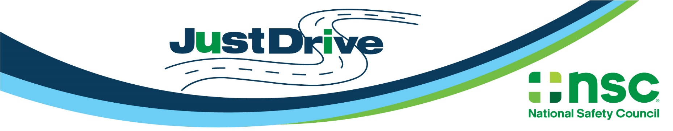

Distracted Driving Awareness Month - Social Media Kit & Facebook Frame Instructions
Social Media Kit Instructions:
- Download images from their boxes.
- You may use the post suggestions provided or simply use them as inspiration to create your own posts.
- Always include the #justdrive hashtag. This ensures we’ll all be part of the same social conversation!
- Be sure to tag the National Safety Council in your posts. Type out and select ‘@National Safety Council’ in Facebook and LinkedIn posts for proper tagging.
- You can also share messages from the NSC social media pages by clicking ‘share’ in each platform. We’ll be sharing additional posts throughout the month of April.
  - Facebook
  - LinkedIn
  - Twitter
  - Instagram
Questions? Contact Al.Lagattolla@nsc.org.

Images | Facebook/LinkedIn Post | Twitter Post
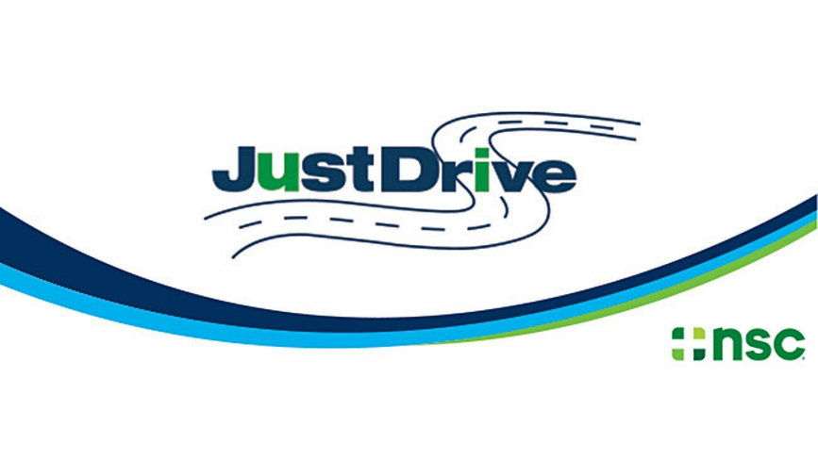 | This April for Distracted Driving Awareness Month, take the @National Safety Council #JustDrive pledge and commit to driving distraction-free: nsc.org/pledge | This April for Distracted Driving Awareness Month, take the @nscsafety #JustDrive pledge and commit to driving distraction-free: nsc.org/pledge
 | Our roads are more dangerous, but your support can make a difference. During Distracted Driving Awareness Month, consider a donation to the @National Safety Council to help keep youyou’re your loved ones safe on the road: http://bit.ly/JustDriveDonate  #JustDrive | Our roads are more dangerous, but your support can make a difference. During Distracted Driving Awareness Month, consider a donation to @NSCSafety to help keep you and your loved ones safe on the road: http://bit.ly/JustDriveDonate  #JustDrive
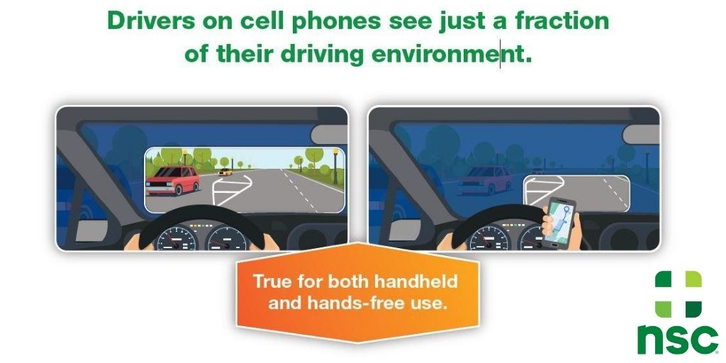 | If you use your cell phone while driving, you’re taking your eyes off the road. Distracted driving can be deadly. #JustDrive Learn more from the @National Safety Council at http://bit.ly/nscddam2021 | If you use your cell phone while driving, you’re taking your eyes off the road. #DistractedDriving can be deadly. #JustDrive Learn more at http://bit.ly/nscddam2021  @nscsafety
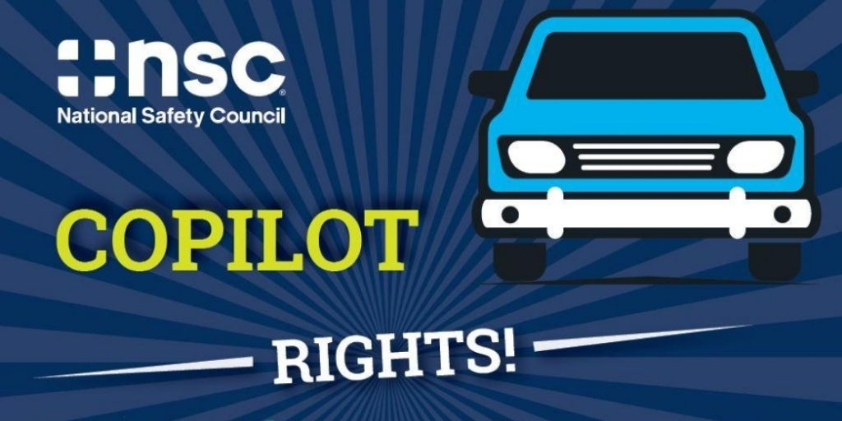 | If your driver is distracted or doing something dangerous, you have the right to speak up! You and everyone else on the road should get home safely.  #JustDrive and get distracted driving resources from the @National Safety Council at http://bit.ly/nscddam2021 | You have the right to speak up if your driver is distracted or doing anything dangerous. Get #distracteddriving resources at http://bit.ly/nscddam2021 #JustDrive @nscsafety
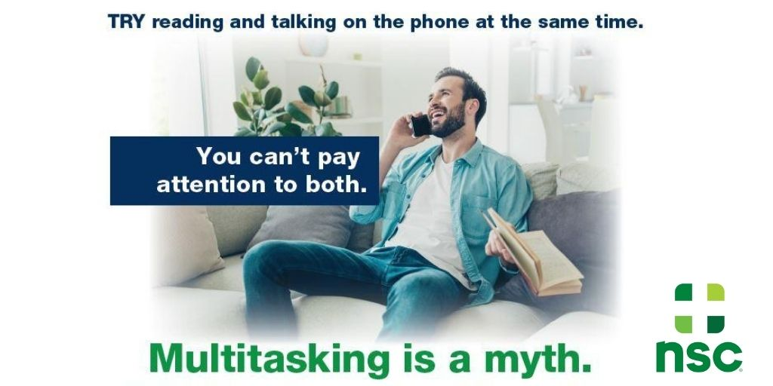 | Multitasking is a myth. Never drive and use your phone at the same time. It’s not worth a crash. #JustDrive and learn more from the @National Safety Council at http://bit.ly/nscddam2021 | Multitasking is a myth. Never drive and use your phone at the same time. It’s not worth a crash. #JustDrive and learn more from @nscsafety at http://bit.ly/nscddam2021
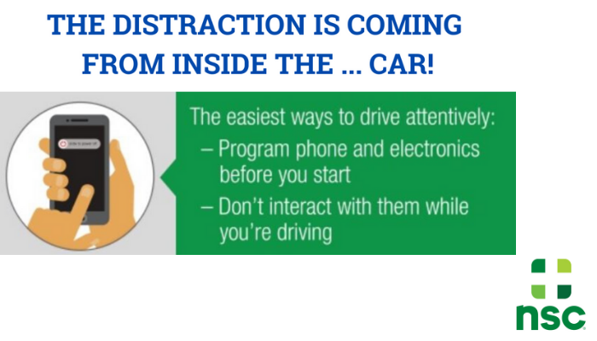 | A dangerous distraction is coming from inside your own car – your cell phone!  Get set up when you get in your car, then #JustDrive. Your life is worth more than any call, text or playlist. Learn more from the @National Safety Council at http://bit.ly/nscddam2021 | A dangerous distraction is coming from inside your own car – your cell phone! Get set up when you get in your car, then #JustDrive. Your life is worth more than any call, text or playlist. Learn more from @nscsafety at http://bit.ly/nscddam2021

Videos To Share | Facebook/LinkedIn Post | Twitter Post
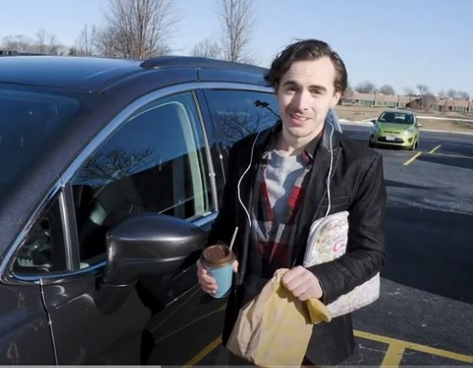  “Set Up Your Drive” Video  Copy and paste this link in your social post: https://youtu.be/fuLViQVELug | Distractions can be deadly. Set up your car before you start your trip, then #JustDrive. Learn more from the @National Safety Council at http://bit.ly/nscddam2021 | Distractions can be deadly. Set up your car before you start your trip, then #JustDrive. Learn more @nscsafety at http://bit.ly/nscddam2021.
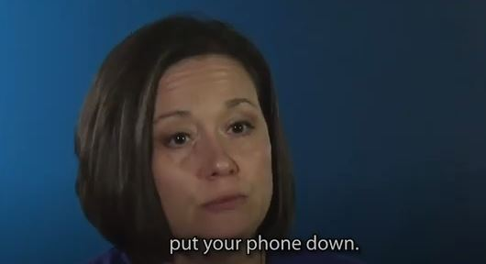  “It Can Cost You Your Life” Video  Copy and paste this link in your social post: https://www.youtube.com/watch?v=WRfMBEMmtrQ | “For your life, your passengers, or for those around you on the road, put your phone down.”  Distracted driving took Camryn, Michelle Lunsford’s only child. Michelle’s message: A bad decision can cost you your life. #JustDrive. Learn more from the @National Safety Council at http://bit.ly/nscddam2021 | “For your life, your passengers, or for those around you on the road, put your phone down.”  Distracted driving took Camryn, Michelle Lunsford’s only child. Michelle’s message: A bad decision can cost you your life. #JustDrive. Learn more at http://bit.ly/nscddam2021 @nscsafety

Kids in Hot Cars - National Safety Council (nsc.org)

https://youtu.be/WRfMBEMmtrQ

Facebook Frame Instructions:
Option 1: Change it on your Facebook page
Step 1: Go to your own Facebook profile. Find your profile page by clicking on your icon in the top left corner of your news feed.
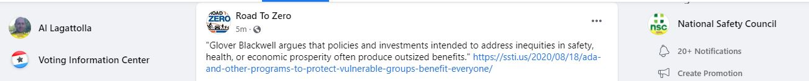

Step 2: Click the camera icon on your profile photo and then select “Update Profile Picture"
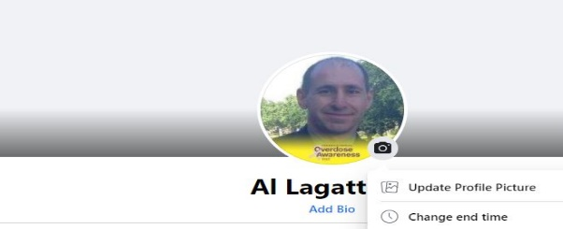
Step 3: Once you click “Update,” a box should appear with photos. Look at the top of the auto-populate box and select “Add Frame.”
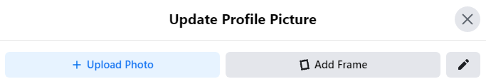
Step 4: Type “Distracted Driving Awareness Month 2021” in the search field in the top left corner, and the frame that says "Just Drive” will appear. Select that frame and crop your profile filter however you see fit. You can decide how long you want to use the frame, then click, “Use as Profile Picture.”

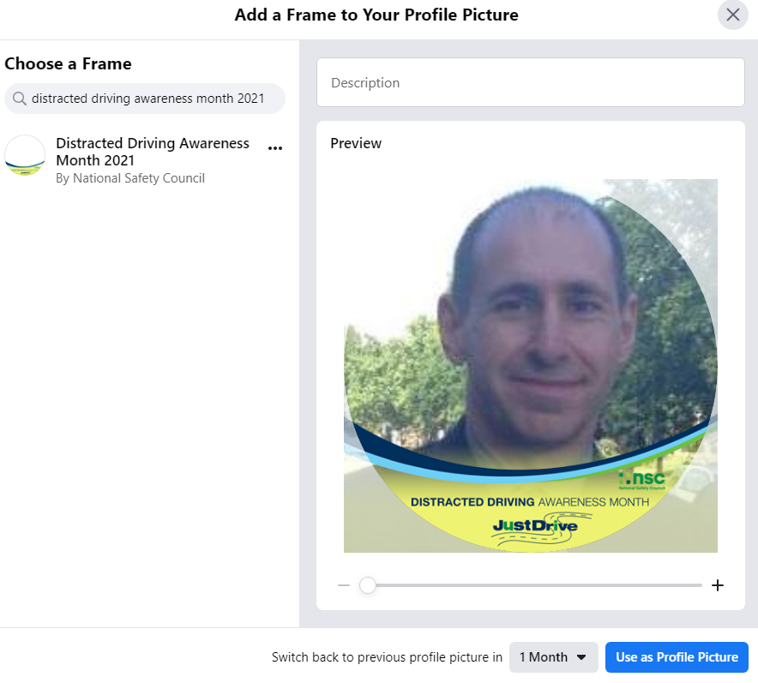

Option 2: Straight from the NSC Post
  - NSC will publish a post on April 1 highlighting the filter and announcing the start of Distracted Driving Awareness Month. On the post, click the photo, and you'll see an area that invites you to "Change Your Profile Picture." Select the Facebook Frame - or search for it - then click "Use as Profile Picture."
Questions? Contact Al.Lagattolla@nsc.org.

